The requested changes are as follows:

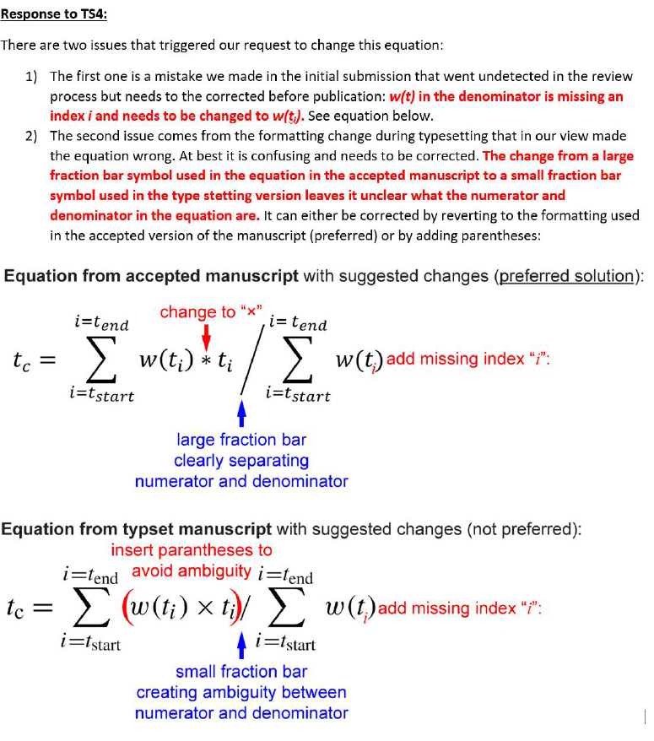
Page 15, equation below TS4:

